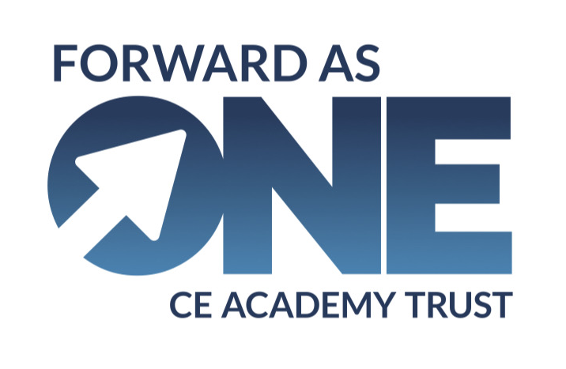

Safeguarding and Child protection policy
This policy was approved by the Trustees on 01/09/2026
Chair of Trustees
Adopted on 01/09/2026
This policy will be reviewed annually on or before 01/09/2027

Contents
1 Version control 2
2 Our strong safeguarding culture 2
3 Procedure if you have concerns about a child’s welfare (KCSIE, 2026) 4
4 Safeguarding legislation and guidance 5
5 Roles and responsibilities 5
6 Children who may be particularly vulnerable 8
7 Children with special educational needs, disabilities or health issues 8
8 Children who are absent from education 9
9 Alternative provision 9
10 Mental health 9
11 Children who are lesbian, gay or bisexual 10
12 Children who are questioning their gender 10
13 Child-on-child abuse 12
14 Serious violence 15
15 Child Criminal Exploitation (CCE) and Child Sexual Exploitation (CSE) 15
16 County lines 17
17 Sharing nudes and semi-nudes 18
18 Online safety 19
19 Handheld devices and cameras 20
20 Domestic abuse 21
21 Honour or faith-based abuse 21
22 Radicalisation and extremism 22
23 Staff/pupil relationships 23
24 Safeguarding concerns and allegations made about staff, including supply teachers, volunteers, and contractors 23
25 Whistle blowing if you have concerns about a colleague 23
26 Staff and governor/trustee training 23
27 Safer recruitment 24
28 Site security 25
29 Child protection procedures 25
30 Referral to children’s social care 26
31 Reporting directly to child protection agencies 27
32 Confidentiality and sharing information 27
33 Special circumstances 27
Appendix One - Four categories of abuse 30
Appendix Two – Body map guidance 33
Appendix Three – Allegations of abuse made against staff 38
Appendix Four – Tracking form: concerns raised against staff 46
Appendix Five - Statement of Staff Commitment to the Forward As One Safeguarding & Child Protection Policy 49
Appendix Six – Criminal records self-declaration form 50
Appendix Seven - Related safeguarding policies 52
- Version control
Version | Date | Author | Changes
September 2026 | September 2026 | L Coleman | Complete new policy adopted due to significant changes to KCSIE 2026.

- Our strong safeguarding culture
Why it is important
Safeguarding is everyone’s responsibility and it is the duty of the academy and Forward As One CE MAT to safeguard and promote the welfare of children. ‘Children’ includes everyone under the age of 18. This is our core safeguarding principle.
In adhering to this principle, we focus on providing a safe and welcoming environment for all our children regardless of age, ability, culture, race, language, religion, gender identity, or sexual identity. All our children have equal rights to support and protection.
One of the cornerstones of our safeguarding culture is this policy and the procedures contained within it. This policy applies to all staff, volunteers, and governors, all of whom are trained upon its contents and on their safeguarding duties. We update this policy at least annually to reflect changes to law, guidance, and best practice.
This policy should be read alongside our other safeguarding policies, which are set out in Appendix Two.
What it means for our pupils
We work with our local safeguarding partners to promote the welfare of children and protect them from harm. This includes providing a co-ordinated offer of early help when additional needs of children are identified, and contributing to inter-agency plans, which provide additional support to the child. It also includes contributing to broader, multi-agency strategic discussions about safeguarding children.
All our staff have an equal responsibility to act on any suspicion or disclosure that may indicate that a child is at risk of harm. Any pupils or staff involved in child protection or safeguarding issue will receive appropriate support.
Our strong safeguarding culture ensures that we treat all pupils with respect and involve them in decisions that affect them. We encourage positive, respectful, and safe behaviour among pupils and we set a good example by conducting ourselves appropriately.
Identifying safeguarding and child protection concerns often begin with recognising changes in pupils’ attendance and/or behaviour and knowing that these changes may be signs of abuse, neglect, or exploitation. Challenging behaviour may be an indicator of abuse.
All our staff will reassure children that their concerns and disclosures will be taken seriously, and that they will be supported and kept safe.
- Procedure if you have concerns about a child’s welfare (KCSIE, 2026)
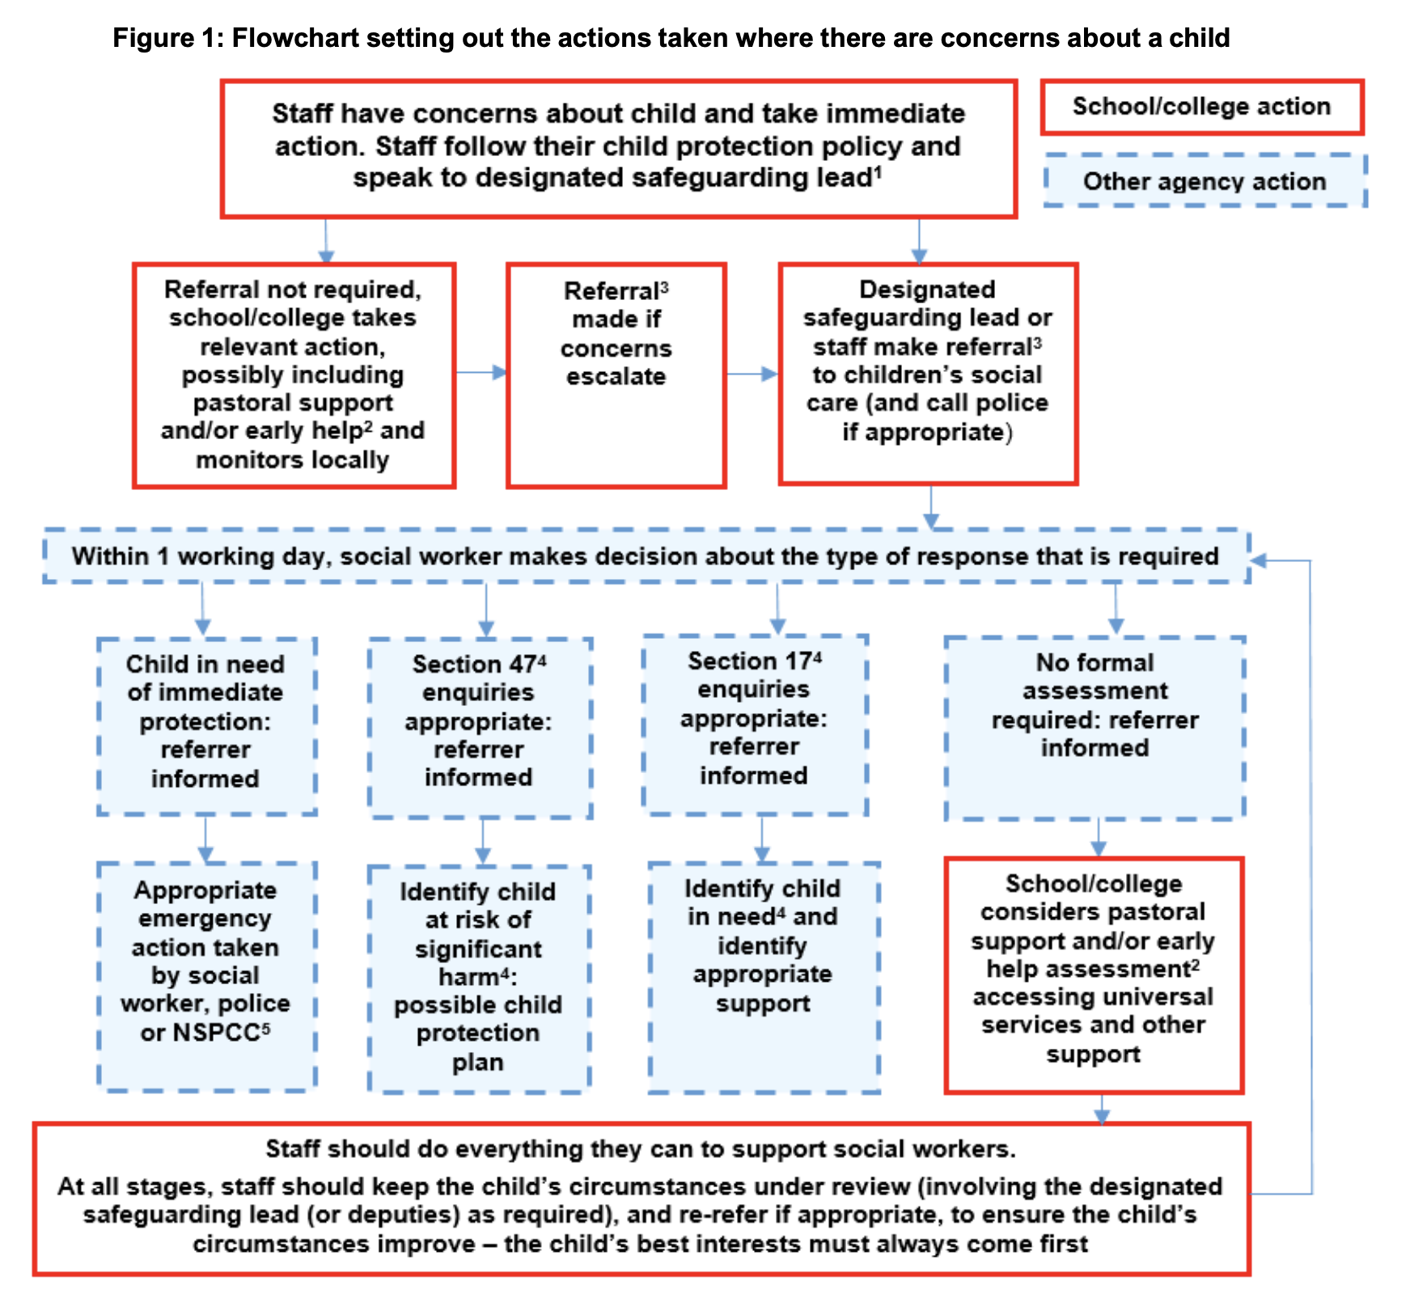
3.1 In cases which also involve a concern or an allegation of abuse against a staff member, see Part four of KCSIE 2026.
3.2 Family Help means providing support as soon as a problem emerges at any point in a child’s life. Where a child would benefit from co-ordinated Family Help, a family help inter-agency assessment should be arranged. Working Together to Safeguard Children provides detailed guidance on the Family Help process.
3.3 Referrals should follow the process set out in the local threshold document and local protocol for assessment. See Working Together to Safeguard Children.
3.4 Under the Children Act 1989, local authorities are required to provide services for children in need for the purposes of safeguarding and promoting their welfare. Children in need may be assessed under section 17 of the Children Act 1989. Under section 47 of the Children Act 1989, where a local authority has reasonable cause to suspect that a child is suffering or likely to suffer significant harm, it has a duty to make enquiries to decide whether to take action to safeguard or promote the child’s welfare. Full details are in Working Together to Safeguard Children.
3.5 This could include applying for an Emergency Protection Order (EPO).

- Safeguarding legislation and guidance
The following safeguarding legislation and guidance has been considered when drafting this policy:
- Keeping Children Safe in Education (2026)
- Working Together to Safeguarding Children (2026)
- What to do if you’re worried a child is being abused (2015)
- Prevent Duty guidance: Guidance for specified authorities in England and Wales (2023)
- The Teacher Standards 2012
- The Safeguarding Vulnerable Groups Act 2006
- Section 157 of the Education Act 2002
- The Education (Independent School Standards) Regulations 2014
- The Domestic Abuse Act 2021
- PACE Code C 2019
- Crime and Policing Act 2026
- Statutory Framework for the Early Years Foundation Stage (EYFS)
4.2
Our 7 local safeguarding partners are:
Bolton https://www.boltonsafeguardingchildren.org.uk
Bury https://burysafeguardingpartnership.bury.gov.uk/
Lancashire https://www.safeguardingpartnership.org.uk
Manchester https://www.manchestersafeguardingpartnership.co.uk/
Oldham https://www.olscb.org/
Rochdale https://rochdalesafeguarding.com/rbsp
Tameside https://www.tameside.gov.uk/Tameside-Safeguarding-Children-Partnership

- Roles and responsibilities

Role/organisation | Name | Contact details
Designated safeguarding lead (DSL) Head of School | Natalie Paice | 0161 725 9750  gorsefield@bury.gov.uk
Deputy DSL | Lindsey Ireland | 0161 725 9750  gorsefield@bury.gov.uk
Headteacher | Ruth Onyekaba | 0161 725 9750  gorsefield@bury.gov.uk
Chair of Governors | Emma Wynne Jones | 0161 725 9750  gorsefield@bury.gov.uk
Safeguarding Governor | Emma Wynne Jones | 0161 725 9750  gorsefield@bury.gov.uk
Safeguarding Trustee | Peter Bond | bondp@fa1.uk
Trust Safeguarding Lead | Lynsey Coleman | colemanl@sta.fa1.uk
Designated teacher for LAC/SENDCo | Amy Tunstall | 0161 725 9750  sendco@gor.fa1.uk
Mental Health Lead | Lindsey Ireland | 0161 725 9750  gorsefield@bury.gov.uk
Allergy Safety Lead | Ruth Onyekaba | 0161 725 9750  gorsefield@bury.gov.uk
Prevent Lead | Natalie Paice | 0161 725 9750  gorsefield@bury.gov.uk
Channel helpline |  | 020 7340 7264
Children’s Social Care - MASH | Duty Social Worker | 0161 253 5678
Local authority designated officer (LADO) |  | 0161 253 6606/0161 253 5678  LADO@bury.gov.uk

The designated safeguarding lead (DSL):
The designated safeguarding lead takes lead responsibility for safeguarding and child protection (including online safety) in the academy. The DSL duties include:
- Ensuring child protection policies are known, understood, and used appropriately by staff.
- Working with the Trust safeguarding Lead, board of trustees and LAB to ensure that the Trust’s child protection policies are reviewed annually and that the procedures are reviewed regularly.
- Acting as a source of support, advice, and expertise for all staff on child protection and safeguarding matters.
- Liaising with the headteacher regarding ongoing enquiries under section 47 of the Children Act 1989 and police investigations and being aware of the requirement for Children to have an Appropriate Adult in relevant circumstances.
- Acting as a point of contact with the safeguarding partners.
- Making and managing referrals to children’s social care, the police, or other agencies.
- Keeping detailed, accurate, secure written records of concerns, discussions, and decisions made including the rationale for those decisions (including where referrals were or were not made).
- Taking part in strategy discussions, and inter-agency meetings.
- Liaising with the ’case manager‘ and the designated officer(s) at the local authority if allegations are made against staff.
- Making staff aware of training courses and the latest local safeguarding arrangements available through the local safeguarding partner arrangements.
- Transferring the child protection file to a child’s new school.
- EYFS - Work with the headteacher to ensure that the relevant staffing ratios are met, where applicable.
- EYFS - Work with the headteacher to ensure that each EYFS child is assigned a key person.
The deputy designated safeguarding lead(s):
Our deputy DSL(s) is/are trained to the same level as the DSL and support(s) the DSL with safeguarding matters on a day-to-day basis. The ultimate lead responsibility for child protection remains with the DSL.
The safeguarding governor/trustee
The role of the safeguarding governor/trustee is to provide support and challenge to the DSL and the leadership of the school/trust on how they manage safeguarding so that the safety and wellbeing of the children can continuously improve. The role includes:
- Understanding the requirements of the Governance Handbook and Keeping Children Safe in Education 2026.
- Supporting and challenging the DSL on the standards of safeguarding at the school/trust.
- Confirming that consistent and compliant safeguarding practice takes place across the school/trust.
- Reporting to the board of trustees about the standard of safeguarding in the school/trust.
The DSL and the safeguarding governor meet on a regular basis to discuss safeguarding issues and to agree steps to continuously improve safeguarding practices in the school.
- Children who may be particularly vulnerable
Some children are at greater risk of abuse, neglect, and exploitation. This increased risk can be caused by many factors including social exclusion, isolation, discrimination, and prejudice. To ensure that all our pupils receive equal protection, we give special consideration to children who:
- Are vulnerable because of their race, ethnicity, religion, special educational needs, disability, gender identity or sexuality.
- Are young carers.
- Are pregnant or are parents themselves.
- Are involved in the court system or have a family member in prison.
- Are vulnerable to being bullied or engaging in bullying.
- Are at risk of sexual exploitation, forced marriage, female genital mutilation, or being drawn into extremism.
- Live in chaotic or unsupportive home situations.
- Live transient lifestyles or live away from home or in temporary accommodation.
- Are affected by parental substance abuse, domestic abuse, or parental mental health needs.
- Do not have English as a first language.
- Experience or have experienced bereavement or mental health difficulties.
- Are in care or privately fostered or have returned home to their family from care.
- Have experienced multiple suspensions and are at risk of, or have been, permanently excluded.
- Children with special educational needs, disabilities or health issues
Children with special educational needs or disabilities (SEND) or certain medical or physical health conditions can face additional safeguarding challenges. Additional barriers can exist when recognising abuse, neglect, and exploitation in this group of children, which can include:
- Assumptions that indicators of possible abuse such as behaviour, mood, and injury relate to the child’s disability without further exploration.
- Being more prone to peer group isolation that other children.
- The potential for children with SEND or certain medical conditions being disproportionally impacted by behaviours such as bullying, without outwardly showing any signs;
- Communication barriers and difficulties in overcoming these barriers
- The need for intimate care or that these children are isolated from others.
- That these children are more likely to be dependent on adults for care.
- These children may have issues over cognitive understanding – being unable to understand the difference between fact and fiction in online content and then repeating the content/behaviours in school or the consequences of doing so.

Our staff are trained to be aware of and identify these additional barriers to ensure this group of children are appropriately safeguarded.
- Children who are absent from education
Children being absent from education for prolonged periods, on an increasing basis and/or on repeat occasions, and children with unexplainable and/or persistent absences from education, can be an indicator of abuse, neglect and exploitation, including sexual abuse or exploitation, trafficking, modern slavery, child criminal exploitation, mental health problems, risk of travelling to conflict zones, risk of female genital mutilation or risk of forced marriage. Our staff are alert to these risks.
We closely monitor attendance, absence, and exclusions and our DSL will take appropriate and proactive action including notifying the local authority, particularly where children go missing on repeated occasions, on an increasing basis and/or are missing for periods during the school day.
The DSL will inform the Trust Safeguarding Lead of any child whose attendance drops below 65%.
- Alternative provision
Where a pupil is placed with an alternative provision provider, we continue to be responsible for the safeguarding of that pupil and will ensure we are satisfied that the placement meets the pupil’s needs.
- Mental health
Schools have an important role to play in supporting the mental health and wellbeing of their pupils.
All staff are aware that mental health problems can be an indicator that a child has suffered, or is at risk of suffering abuse, neglect or exploitation, and that in some cases they can develop into safeguarding concerns. Staff are also aware that where children have suffered adverse childhood experiences those experiences can impact on their mental health, behaviour, and education.
All staff are aware that there are potential warning signs when a child is struggling with their mental health. These include:
    - Significant changes in behaviour
    - Ongoing difficulty sleeping
Withdrawing from social situations
Not wanting to do things they usually like; and
Physical signs of self-harm or neglecting themselves
Where staff are concerned that a child’s mental health is also a safeguarding concern, they will discuss it with the DSL or a deputy who will alert other relevant agencies as necessary.
- Children who are lesbian, gay or bisexual
The fact that a child or a young person may be lesbian, gay, or bisexual is not in itself an inherent risk factor for harm. Unfortunately, children who are lesbian, gay, or bisexual, or are simply perceived to be lesbian, gay, or bisexual, can be vulnerable to discriminatory bullying by other children. The risk to these children can be compounded where children who are lesbian, gay, or bisexual lack a trusted adult with whom they can be open.
Our staff endeavour to reduce the barriers and provide a safe space for those children to speak out or share their concerns with them.
- Children who are questioning their gender
The school will take a sensitive, child-centred approach to pupils who are questioning their gender identity or who have the protected characteristic of gender reassignment, having regard at all times to the welfare of the individual pupil and the welfare of other pupils.
The school will respect both gender-critical and gender-affirming beliefs held within the school community and will not tolerate bullying, harassment, or discrimination in connection with any such beliefs.
The school will not initiate any social transition actions. Where a child, parent, or carer requests support in relation to gender identity, including any form of social transition (such as changes to name, pronouns, or presentation), the school will only implement any changes following a school-level decision made in accordance with the following process:
DSL involvement: The designated safeguarding lead ("DSL") will be informed and involved in the decision-making process from the outset, as gender-related requests may intersect with safeguarding considerations.
Parental engagement: Parents and carers will be engaged as a matter of priority and their views treated with importance. The school will not implement any social transition arrangements without parental knowledge and engagement, save in the exceptional circumstances described in paragraph 12.3.3 below.
Exception to parental engagement: Where staff have reasonable grounds to conclude that involving parents or carers would create a greater risk of harm to the child, the DSL will determine what safeguarding action is appropriate before parents are contacted and before any decision is taken. Any decision to proceed without parental engagement will be documented with clear reasons.
Professional advice: Where appropriate, the school will seek advice from relevant professionals, which may include the school's special educational needs coordinator ("SENCO"), relevant health professionals, or the local authority designated officer ("LADO") where applicable. The school will be alert to the possibility that gender-questioning presentations may co-occur with, or be influenced by, other factors including neuro-developmental conditions, mental health difficulties, or other needs.
Cautious approach: The Trust will take a careful and considered approach, recognising that social transition is an active intervention with potentially significant consequences. In primary schools, support for full social transition will be agreed only in very rare circumstances.
Record-keeping: All discussions, decisions, and the reasons for those decisions will be recorded in writing and stored securely and confidentially. Records will be kept under review and revisited if circumstances change.
Review: Any agreed arrangements will be subject to periodic review. Where circumstances change, the DSL will be informed immediately and arrangements will be reassessed.
The school will ensure that its facilities arrangements comply with its legal obligations in relation to biological sex and with its safeguarding duties.
Toilets: The school will not permit a child to use toilet facilities designated for the opposite biological sex. Where a pupil does not wish to use toilet facilities designated for their biological sex, the school will consider whether an alternative arrangement, such as a self-contained individual toilet, can be provided without compromising single-sex provision or the safety, comfort, privacy, or dignity of the pupil or other pupils. Any such arrangement will be recorded and reviewed regularly.
Changing rooms and showers: The school will not permit a pupil aged 11 or over to undress in the presence of a pupil of the opposite biological sex and will not permit access to changing rooms or shower facilities designated for the opposite biological sex as part of any social transition arrangements. Where a pupil does not wish to use facilities designated for their biological sex, the school will consider alternative arrangements that do not compromise single-sex provision, and will keep clear records, communicate appropriately, and review regularly.
Overnight accommodation: The school will not permit a pupil to share overnight accommodation with a pupil of the opposite biological sex. Where a pupil does not wish to share accommodation with a pupil of the same biological sex, the school will seek to identify alternative arrangements where possible without compromising safety, comfort, privacy, or dignity, and will document those arrangements.
For safeguarding purposes, relevant staff will be made aware of a pupil's biological sex in all cases, and a pupil's biological sex will be recorded accurately wherever it is recorded by the school.
- Child-on-child abuse
Child-on-child abuse – children harming other children - is unacceptable and will be taken seriously; it will not be tolerated or passed off as ‘banter’, ‘just having a laugh’, ‘part of growing up’ or ‘boys being boys’. The school takes a zero-tolerance approach to sexual harassment and sexual violence; it is never acceptable, and it will not be tolerated.
It is more likely that boys will be perpetrators of child-on-child abuse and girls’ victims, but allegations will be dealt with in the same manner, regardless of whether they are made by boys or girls.
All staff are aware that child-on-child abuse is a safeguarding issue for both the victim and alleged perpetrator, and they are clear about the school’s policy and procedures for addressing child-on-child abuse and maintain an attitude of ‘it could happen here’.
Child-on-child abuse can take many forms, including:
- Physical abuse such as shaking, hitting, biting, kicking or hair pulling.
- Bullying, including cyberbullying, prejudice-based and discriminatory bullying.
- Sexual violence such as rape, assault by penetration and sexual assault (this may include an online element which facilitates, threatens and/or encourages sexual violence).
- Sexual harassment such as sexual comments, remarks, jokes and online sexual harassment, which may be standalone or part of a broader pattern of abuse and which may include misogyny/misandry.
- Serious physical assault and harm, or the threat of harm with a weapon.
- Causing someone to engage in sexual activity without consent, such as forcing someone to strip, touch themselves sexually, or to engage in sexual activity with a third party.
- Up skirting, which involves taking a picture under a person’s clothing without their permission for the purposes of sexual gratification or to cause humiliation, distress or alarm.
- Consensual and non-consensual making or sharing of nude and semi-nude images and/or videos (including those generated by AI), and including pressuring others to share sexual content.
- Abuse in intimate personal relationships between children (also known as teenage relationship abuse) - such as a pattern of actual or threatened acts of physical, sexual or emotional abuse.
- Initiation/hazing – used to induct newcomers into sports teams or school groups by subjecting them to potentially humiliating or abusing trials with the aim of creating a bond.
Different gender issues can be prevalent when dealing with child-on-child abuse, for example girls being sexually touched/assaulted or boys being subject to initiation/hazing type violence.
All staff recognise that that even if there are no reported cases of child-on-child abuse, such abuse may still be taking place but is not being reported.
Minimising risk
We take the following steps to minimise or prevent the risk of child-on-child abuse:
- Promoting an open and honest environment where children feel safe and confident to share their concerns and worries.
- Using assemblies to outline acceptable and unacceptable behaviour.
- Using RSE and PSHE to educate and reinforce our messages through stories, role play, current affairs, and other suitable activities.
- Ensuring that the school is well supervised, especially in areas where children might be vulnerable.
Investigating allegations
All allegations of child-on-child abuse should be passed to the DSL immediately who will investigate and manage the allegation as follows:
- Gather information - children and staff will be spoken with immediately to gather relevant information.
- Decide on action - if it is believed that any child is at risk of significant harm, a referral will be made to children’s social care. The DSL will then work with children’s social care to decide on next steps, which may include contacting the police. In other cases, we may follow our behaviour policy alongside this Child Protection and Safeguarding Policy.
- Inform parents - we will usually discuss concerns with the parents. However, our focus is the safety and wellbeing of the pupil and so if the school believes that notifying parents could increase the risk to a child or exacerbate the problem, advice will first be sought from children’s social care and/or the police before parents are contacted.
- Record – all concerns, discussions and decisions made, and the reasons for those decisions will be recorded in writing, kept confidential and stored securely on the school’s child protection and safeguarding systems in the child’s profile. The record will include a clear and comprehensive summary of the concern, details of how the concern was followed up and resolved, and a note of the action taken, decisions reached, and the outcome.
Where allegations of a sexual nature are made, the school will follow the statutory guidance set out in Part 5 of Keeping Children Safe in Education 2026. The DSL will decide on a case-by-case basis whether to carry out an immediate risk and needs assessment.
Reports of rape or assault by penetration are especially serious. While the school establishes the facts and liaises with children’s social care and the police, the alleged perpetrator(s) may be removed from any shared classes with the victim. The school will also consider how to maintain a reasonable physical separation between the victim and alleged perpetrator(s) across school, including before or after school-based activities, and on transport to and from the school.
Children can report allegations or concerns of child-on-child abuse to any staff member and that staff member will pass on the allegation to the DSL in accordance with this policy. To ensure children can report their concerns easily, the school has the following system in place for children to confidently report abuse:
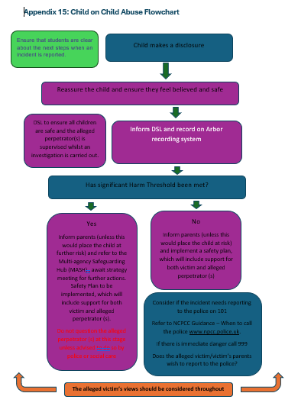
Our staff reassure all victims that they are being taken seriously, regardless of how long it has taken them to come forward, and that they will be supported and kept safe. Our staff will never give a victim the impression that they are creating a problem by reporting sexual violence or sexual harassment, nor will victims be made to feel ashamed for making a report.
Abuse that occurs online or outside of school will not be downplayed and will be treated equally seriously. We recognise that sexual violence and sexual harassment occurring online can introduce a number of complex factors. Amongst other things, this can include widespread abuse or harm across a number of social media platforms that leads to repeat victimisation.
The support required for the pupil who has been harmed will depend on their particular circumstance, and the nature of the abuse. The support we provide could include counselling and mentoring or restorative justice work.
Support may also be required for the pupil who caused harm. We will seek to understand why the pupil acted in this way and consider what support may be required to help the pupil, and/or change behaviours. The consequences for the harm caused or intended will be addressed.
- Serious violence
Serious violence is a continuing safeguarding concern which may involve physical assault, carrying, threatening with, or using weapons, often in the context of peer conflict or bullying, and criminal exploitation. All staff are aware of the signs that a child may be at risk of or involved in serious violence, including:
An increased absence from school or college or a significant decline in educational performance.
A change in friendships or relationships with older individuals or groups.
Signs of self-harm or a significant change in wellbeing, or signs of assault or unexplained injuries, and
Unexplained gifts or new possessions could also indicate that children have been approached by, or are involved with, individuals associated with criminal networks or gangs and may be at risk of criminal exploitation.
- Child Criminal Exploitation (CCE) and Child Sexual Exploitation (CSE)
Both CCE and CSE are forms of abuse and both occur where an individual or group takes advantage of an imbalance of power to coerce, manipulate, or deceive a child into taking part in sexual or criminal activity in exchange for something the victim needs or wants, and/or for the financial advantage or increased status of the perpetrator or facilitator and/or through violence or the threat of violence. This power imbalance can be due to a range of factors, including:
Age
Gender
Sexual identity
Cognitive ability
Physical strength
Status
Access to economic or other resources
The abuse can be perpetrated by individuals or groups, males or females, and children or adults. It can also be perpetrated by an organised network or gang, and the victim may identify as being part of this group. They can be one-off occurrences or a series of incidents over time and may or may not involve force or violence. Exploitation can be physical and take place online.
CCE and CSE can affect children, both male and female, and can include children who have been moved (commonly referred to as trafficking) for the purpose of exploitation. This may constitute modern slavery.
Child Criminal Exploitation (CCE)
CCE can include children being forced or manipulated into transporting drugs or money through county lines, working in cannabis factories, shoplifting or pickpocketing, being forced or manipulated into committing vehicle crime or threatening/committing serious violence to others.
Children can become trapped by this exploitation as perpetrators can threaten victims (and their families) with violence or entrap and coerce them into debt. They may be coerced into carrying weapons such as knives or carry a knife for a sense of protection.
Children involved in criminal exploitation often commit crimes themselves. They may still have been criminally exploited even if the activity appears to be something they have agreed or consented to.
It is important to note that the experience of girls who are criminally exploited can be very different to that of boys, and both boys and girls being criminally exploited may be at higher risk of sexual exploitation.
CCE indicators
CCE indicators can include children who:
      - Appear with unexplained gifts or new possessions.
      - Associate with other young people involved in exploitation.
      - Suffer from changes in emotional well-being.
      - Misuse drugs or alcohol.
      - Go missing for periods of time or regularly return home late.
      - Regularly or increasingly miss school or education or do not take part in education.
Child Sexual Exploitation (CSE)
CSE is a form of child sexual abuse which may involve physical contact, including assault by penetration (for example, rape or oral sex) or nonpenetrative acts such as masturbation, kissing, rubbing, and touching outside clothing. It may include non-contact activities, such as involving children in the production of sexual images, forcing children to look at sexual images or watch sexual activities, encouraging children to behave in sexually inappropriate ways, or grooming a child in preparation for abuse.
CSE can occur over time or be a one-off occurrence and may happen without the child’s immediate knowledge, e.g. through others sharing videos or images of them on social media.
CSE can affect any child, who has been coerced into engaging in sexual activities. This includes 16- and 17-year-olds who can legally consent to have sex. CSE can be committed by an individual or an organised network and most sexual abuse is committed by those previously known to the victim. Some children may not realise they are being exploited, e.g. they believe they are in a genuine romantic relationship.
Sexual exploitation is a serious crime and can have a long-lasting adverse impact on a child’s physical and emotional health. It may also be linked to child trafficking.
CSE indicators
The above indicators can also be indicators of CSE, as can children who:
      - Have older boyfriends.
      - Suffer sexually transmitted infections or become pregnant.
We include the risks of criminal and sexual exploitation in our RSE and health education curriculum. It is often the case that the child does not recognise the coercive nature of the exploitative relationship and does not recognise themselves as a victim.
Victims of criminal and sexual exploitation can be boys or girls, and it can have an adverse impact on a child’s physical and emotional health.
All staff are aware of the indicators that children are at risk of or are experiencing CCE or CSE. All concerns are reported immediately to the DSL. Staff must always act on any concerns that a child is suffering from or is at risk of criminal or sexual exploitation.
- County lines
County lines is a term used to describe gangs and organised criminal networks involved in exporting illegal drugs around the country using dedicated mobile phone lines. Children and vulnerable adults are exploited to move, store, and sell drugs and money, with offenders often using coercion, intimidation, violence and weapons to ensure compliance of victims.
County lines exploitation can occur where an individual or group takes advantage of an imbalance of power to coerce, manipulate, or deceive a child. This power imbalance can be due to the same range of factors set out at paragraph 10.1 of this policy.
Children can be targeted and recruited into county lines in a number of locations, including schools and colleges. Indicators of county lines include those indicators set out at 10.3 of this policy, with the main indicator being missing episodes from home and/or school.
Additional specific indicators that may be present where a child is criminally exploited include children who:
- Go missing and are subsequently found in areas away from home.
- Have been the victim or perpetrator of serious violence (e.g. knife crime).
- Are involved in receiving requests for drugs via a phone line, moving drugs, handing over and collecting money for drugs.
- Are exposed to techniques such as ‘plugging’, where drugs are concealed internally to avoid detection.
- Are found in accommodation with which they have no connection or in a hotel room where there is drug activity.
- Owe a ‘debt bond’ to their exploiters.
- Have their bank accounts used to facilitate drug dealing.
All staff are aware of indicators that children are at risk from or are experiencing criminal exploitation. The main indicator is increased absence during which time the child may have been trafficked for the purpose of transporting drugs or money.
- Sharing nudes and semi-nudes
Sharing photos, videos, and live streams online is part of daily life for many children and young people, enabling them to share their experiences, connect with friends and record their lives. Sharing nudes and semi-nudes means the creation, sending, or posting online of nude or semi-nude images, videos, or live streams by young people under the age of 18. This could be via social media, gaming platforms, chat apps, or forums, or carried out offline between devices via services like Apple’s AirDrop.
Images may be taken or created by the child themselves or by another person. They may also be digitally altered or wholly generated using artificial intelligence, including what are sometimes described as ‘deepfakes’ or ‘deep nudes’.
The term ‘nudes’ is used as it is most commonly recognised by young people and more appropriately covers all types of image sharing incidents. Alternative terms used by children and young people may include ‘dick pics’ or ‘pics’. Other terms used in education include ‘sexting’, youth produced sexual imagery’ and ‘youth involved sexual imagery’.
The motivations for taking and sharing nudes and semi-nudes are not always sexually or criminally motivated. Such images may be created and shared consensually by young people who are in relationships, as well as between those who are not in a relationship. It is also possible for a young person in a consensual relationship to be coerced into sharing an image with their partner. Incidents may also occur where:
- Children and young people find nudes and semi-nudes online and share them claiming to be from a peer.
- Children and young people digitally manipulate an image of a young person into an existing nude online.
- Images created or shared are used to abuse peers, e.g. by selling images online or obtaining images to share more widely without consent to publicly shame.
The school takes a safeguarding approach in response to all incidents involving the sharing of nude or semi-nude images, regardless of whether they are consensual or non-consensual. All such incidents require a safeguarding response, with a proportionate approach that considers the age, development, and circumstances of the children involved, as well as any elements of coercion, exploitation, or vulnerability. All incidents involving nude or semi-nude images will be managed as follows:
- The incident will be referred to the DSL immediately and the DSL will discuss it with the appropriate staff. If necessary, the DSL may also interview the children involved.
- Parents will be informed at an early stage and involved in the process unless there is good reason to believe that involving parents would put a child at risk of harm.
- At any point in the process, if there is a concern a young person has been harmed or is at risk of harm, we will refer the matter to the police and/or children’s social care.
The UK Council for Internet Safety updated its advice for managing incidences of sharing nudes and semi-nudes in February 2024 - UKCIS advice 2024 . The school will have regard to this advice when managing these issues.
- Online safety
It is essential that children are safeguarded from potentially harmful and inappropriate online material. As well as educating children about online risks, we have appropriate and effective filtering and monitoring systems in place to limit the risk of children being exposed to inappropriate content, subjected to harmful online interaction with other users and to ensure their own personal online behaviour does not put them at risk. Our filtering and monitoring systems also prevent access to harmful and inappropriate content accessed through generative AI tools and products.
These filtering and monitoring systems block harmful and inappropriate content, and we take care to ensure that they do not unreasonably impact on teaching and learning. The systems are reviewed regularly (at least every academic year) to ensure their effectiveness, and staff have been identified and assigned suitable roles and responsibilities to manage these systems. We also have effective monitoring strategies in place to meet the safeguarding needs of our pupils.
We tell parents and carers what filtering and monitoring systems we use, so they can understand how we work to keep children safe.
We will also inform parents and carers of what we are asking children to do online, including the sites they need to access, and with whom they will be interacting online.
Online safety risks can be categorised into four areas of risk:
- Content: Being exposed to illegal, inappropriate, or harmful content such as pornography, fake news, misogyny, self-harm, suicide, radicalisation, extremism, misinformation, disinformation (including fake news) and conspiracy theories
- Contact: Being subjected to harmful online interaction with other users or generative AI applications that simulate this, such as peer-to-peer pressure and adults posing as children or young adults to groom or exploit children.
- Conduct: Personal online behaviour that increases the likelihood of, or causes, harm such as making, sending and receiving explicit images, sharing other explicit images, including those generated using AI and online bullying.
- Commerce: Risks such as online gambling, inappropriate advertising, phishing or financial scams.
All staff are aware of these risk areas and should report any concerns to the DSL.
- Handheld devices and cameras
The Trust has a separate policy regarding the safe use of mobiles and cameras. This includes:
Personal devices are only to be used by staff when on a designated break away from the pupils. At all other times, personal devices are to be switched off.
School or Trust devices are only to be used by staff for work purposes. Photographs and videos of the pupils are only to be taken on school devices.
Images of the pupils will only be used in accordance with our data protection policy.
- Domestic abuse
The Domestic Abuse Act 2021 introduced a legal definition of domestic abuse and recognises the impact of domestic abuse on children if they see, hear, or experience the effects of abuse.
Domestic abuse is any incident or pattern of incidents of controlling, coercive, threatening behaviour, violence, or abuse, between those aged 16 or over who are, or have been, intimate partners or family members regardless of gender or sexuality. It includes people who have been or are married, are or have been civil partners, have agreed to marry one another or each have or have had a parental relationship in relation to the same child. It can include psychological, physical, sexual, financial, and emotional abuse.
Anyone can be a victim of domestic abuse, regardless of sexual identity, age, ethnicity, socioeconomic status, sexuality, or background and domestic abuse can take place inside or outside of the home. This means children can also be victims of domestic abuse.
Children can witness and be adversely affected by domestic violence in their home life. Experiencing domestic abuse and exposure to it can have a serious emotional and psychological impact on children, and in some cases, a child may blame themselves for the abuse or may have had to leave the family home as a result. All of which can have a detrimental and long-term impact on their health, well-being, development, and ability to learn.
Where police have been called to a domestic violence incident where children are in the household and experienced that incident, the police will inform the DSL. The police will also notify us if they have reasonable grounds to believe a child may be a victim of domestic abuse. This ensures that the school has up to date safeguarding information about the child.
All staff are aware of the impact domestic violence can have on a child. If any of our staff are concerned that a child has witnessed domestic abuse, they will report their concerns immediately to the DSL.
- Honour or faith-based abuse
Honour or faith-based abuse (HBA) encompasses actions taken to protect or defend the honour of the family and/or the community, including female genital mutilation (FGM), forced marriage, and practices such as breast ironing.
Abuse committed in the context of preserving “honour” often involves a wider network of family or community pressure and can include multiple perpetrators. Our staff are aware of this dynamic and additional risk factors and we take them into consideration when deciding what safeguarding action to take.
If staff are concerned that a child may be at risk of HBA or who has suffered from HBA, they should speak to the designated safeguarding lead.
Female genital mutilation
FGM comprises all procedures involving partial or total removal of the external female genitalia or other injury to the female genital organs. It is illegal and a form of child abuse with long-lasting harmful consequences.
FGM is carried out on females of any age, from babies to teenagers to women. Our staff are trained to be aware of risk indicators, including concerns expressed by girls about going on a long holiday during the summer break. If staff are concerned that a child may be at risk of FGM or who has suffered FGM, they should speak to the designated safeguarding lead. Teachers are also under legal duty to report to the police where they discover that FGM has been carried out on a child under 18. In such circumstances, teachers will personally report the matter to the police as well as informing the designated safeguarding lead.
Forced marriage
A forced marriage is one entered into without the full and free consent of one or both parties and where violence, threats, or any other form of coercion is used to cause a person to enter into a marriage. Coercion may include physical, psychological, financial, sexual, and emotional pressure or abuse.
Forced marriage is illegal. It is also illegal to carry out any conduct whose purpose is to cause a child to marry before their eighteenth birthday, even if violence, threats, or another form of coercion are not used. As with the existing forced marriage law, this applies to non-binding, unofficial ‘marriages’ as well as legal marriages.
Our staff are trained to be aware of risk indicators, which may include being taken abroad and not being allowed to return to the UK.
Forced marriage is not the same as arranged marriage, which is common in many cultures.
If staff are concerned that a child may be at risk of forced marriage, they should speak to the designated safeguarding lead.
- Radicalisation and extremism
Extremism is defined as vocal or active opposition to our fundamental values, including democracy, the rule of law, individual liberty and mutual respect and tolerance of different faiths and beliefs. Radicalisation refers to the process of a person legitimising support for, or use of terrorist violence.
Children are vulnerable to extremist ideology and radicalisation. Whilst Islamic fundamentalism is the most widely publicised, extremism and radicalisation can occur in other cultures, religions, and beliefs, including the far right and white supremacy. Our staff are trained to identify those at risk of being radicalised or drawn into extremism.
If staff are concerned that a child may be at risk of radicalisation or being drawn into extremism, they should speak to the designated safeguarding lead.
- Staff/pupil relationships
Staff are aware that inappropriate behaviour towards pupils is unacceptable and that it is a criminal offence for them to engage in any sexual activity with a pupil under the age of 18.
We provide our staff with advice regarding their personal online activity, and we have clear rules regarding electronic communications and online contact with pupils. It is considered a serious disciplinary issue if staff breach these rules.
Our Staff Code of Conduct sets out our expectations of staff and is signed by all staff members.
- Safeguarding concerns and allegations made about staff, including supply teachers, volunteers, and contractors
If a safeguarding concern or allegation is made about a member of staff, supply teacher, volunteer, or contractor, or relates to incidents that happened when an individual or organisation was using the school premises for the purposes of running activities for children our set procedures must be followed. Our safeguarding concerns and allegations made about staff, supply teachers, volunteers, and contractors procedure can be accessed below in appendix 3 and the full procedure for managing such allegations or concerns are set out in Part Four of Keeping Children Safe in Education 2026.
Safeguarding concerns or allegations made about staff who no longer work at the school will be reported to the police.
- Whistle blowing if you have concerns about a colleague
It is important that all staff and volunteers feel able to raise concerns about a colleague’s practice. All such concerns should be reported to the headteacher, unless the complaint is about the headteacher, in which case concern should be reported to the chair of governors.
Staff may also report their concerns directly to children’s social care, LADO or the police if they believe direct reporting is necessary to secure action.
The school’s whistleblowing policy allows staff to raise concerns or make allegations and for an appropriate enquiry to take place.
- Staff and governor/trustee training
Our staff receive appropriate safeguarding and child protection training (including online safety and an understanding of the expectations, applicable roles and responsibilities in relation to filtering and monitoring) which is regularly updated. In addition, all staff receive safeguarding and child protection updates on a regular basis to ensure they are up to date and empowered to provide exceptional safeguarding to our pupils.
New staff and volunteers receive a briefing during their induction which covers this Child Protection and Safeguarding policy and our staff behaviour policy, how to report and record concerns and information about our designated safeguarding lead and deputy DSLs.
Our governors/trustees receive appropriate safeguarding and child protection (including online safety and an understanding of the expectations, applicable roles and responsibilities in relation to filtering and monitoring) training at induction which equips them with the knowledge to provide strategic challenge to test and assure themselves that there is an effective whole trust approach to safeguarding. This training is updated at least annually.
Our safeguarding governor/trustee receives additional training to empower them to support and challenge the designated safeguarding lead and support the delivery of high-quality safeguarding across the trust.
- Safer recruitment
The governing body and our senior leadership team are responsible for ensuring that we follow recruitment procedures which help to deter, reject, or identify people who might harm children. When doing so we check and verify the applicant’s identity, qualifications, and work history in accordance with Keeping Children Safe in Education 2026 and the local safeguarding partner arrangements.
All relevant staff (involved in early years settings and/or before or after school care for children under eight) are made aware of the disqualification from childcare guidance and their obligations to disclose to us relevant information that could lead to disqualification.
We ensure that our volunteers are appropriately checked and supervised when in school. We check the identity of all contractors working on site and requests DBS checks where required by Keeping Children Safe in Education 2026. Contractors who have not undergone checks will not be allowed to work unsupervised during the school day.
When using supply staff, we will obtain written confirmation from supply agencies or third-party organisations that staff they provide have been appropriately checked and are suitable to work with children. Trainee teachers will be checked either by the school or by the training provider, from whom written confirmation will be obtained confirming their suitability to work with children.
The trust carries out the mandatory recruitments checks required for safer recruitment and provides the academies with the relevant information to maintain the academy single central record.
- Site security
Visitors are asked to sign in at the school reception and are given a badge, which confirms they have permission to be on site. If visitors have undergone the appropriate checks, they can be provided with unescorted access to the school site. Visitors who have not undergone the required checks will be escorted at all times.
- Child protection procedures
Recognising abuse
Abuse and neglect are forms of maltreatment. Somebody may abuse or neglect a child by inflicting harm or by failing to act to prevent harm. Abuse may be committed by adult men or women and by other children and young people.
Keeping Children Safe in Education 2026 refers to four categories of abuse. These are set out at Appendix One along with indicators of abuse and neglect.
Taking action
Any child could become a victim of abuse. Key points for staff to remember for taking action are:
- In an emergency take the action necessary to help the child, if necessary, call 999.
- Complete a written record of the concern (Arbor/CPOMS) and report your concern to the DSL as soon as possible.
- Share information on a need-to-know basis only and do not discuss the issue with colleagues, friends or family.
If you are concerned about a pupil’s welfare
Staff may suspect that a pupil may be at risk. This may be because the pupil’s behaviour has changed, their appearance has changed, or physical signs are noticed. In these circumstances, staff will give the pupil the opportunity to talk and ask if they are OK.
If the pupil does reveal that they are being harmed, staff should follow the advice below.
Staff are aware that children may not feel ready or know how to tell someone that they are being abused, exploited, or neglected, and/or they may not recognise their experiences as harmful. Children may feel embarrassed, humiliated, or are being threatened, which could be due to their vulnerability, disability and/or sexual orientation or language barriers. This will not prevent our staff from having a professional curiosity and speaking to our DSL if they have concerns about a child.
If a pupil discloses to you
If a pupil tells a member of staff about a risk to their safety or wellbeing, the staff member will:
- Remain calm and not overreact
- Allow them to speak freely
- Not be afraid of silences
- Not ask investigative questions
- Give reassuring nods or words of comfort – ‘I’m so sorry this has happened’, ‘I want to help’, ‘This isn’t your fault’, ‘You are doing the right thing in talking to me’.
- Not automatically offer physical touch as comfort.
- Let the pupil know that in order to help them they must pass the information on to the DSL.
- Tell the pupil what will happen next and give them an opportunity to ask questions about what will happen next.
- Complete a written safeguarding record (Arbor/CPOMS) and alert it to the DSL as soon as possible.
- Report verbally to the DSL even if the child has promised to do it by themselves.
- Let the pupil know when they can expect to be updated or receive more information, emphasising that the pupil can talk to them or the DSL at any time.
Notifying parents
The school will normally seek to discuss any concerns about a pupil with their parents. If the school believes that notifying parents could increase the risk to the child or exacerbate the problem, advice will first be sought from children’s social care and/or the police before parents are notified.
- Referral to children’s social care
The DSL will make a referral to children’s social care if it is believed that a pupil is suffering or is at risk of suffering significant harm. The pupil (subject to their age and understanding) and the parents will be told that a referral is being made, unless to do so would increase the risk to the child.
- Reporting directly to child protection agencies
Staff should follow the reporting procedures outlined in this policy. However, they may also share information directly with children’s social care or the police if they are convinced that a direct report is required or if the designated safeguarding lead, the deputies, the head teacher or the chair of governors are not available, and a referral is required immediately.
- Confidentiality and sharing information
Child protection issues necessitate a high level of confidentiality. Staff should only discuss concerns with the designated safeguarding lead, headteacher, or chair of governors.
Sharing information
The DSL will normally obtain consent from the pupil and/or parents to share child protection information. Where there is good reason to do so, the DSL may share information without consent and will record the reason for deciding to do so.
Information sharing will take place in a timely and secure manner and only when it is necessary and proportionate to do so and the information to be shared is relevant, adequate, and accurate.
Information sharing decisions will be recorded, whether or not the decision is taken to share.
The UK GDPR and the Data Protection Act 2018 do not prevent school staff from sharing information with relevant agencies, where that information may help to protect a child. If any member of staff receives a request from a pupil or parent to see child protection records, they will refer the request to the Data Protection Officer.
Storing information
Child protection information will be stored separately from the pupil’s school file, and the school file will be ‘tagged’ to indicate that separate information is held. It will be stored and handled in line with our retention and destruction policy.
Our confidentiality and information sharing policy and our retention and destruction policy are available to parents and pupils on request.
- Special circumstances
Looked after children
The most common reason for children becoming looked after is as a result of abuse or neglect. The school ensures that staff have the necessary skills and understanding to keep looked after children safe. Appropriate staff have information about a child’s looked after status and care arrangements, including the level of authority delegated to the carer by the authority looking after the child. The designated teacher for looked after children and the DSL have details of the child’s social worker and the name and contact details of the local authority’s virtual head for children in care.
Children who have a social worker
Children may need a social worker due to safeguarding or welfare needs. Local authorities will share this information with us, and the DSL will hold and use this information to inform decisions about safeguarding and promoting the child’s welfare.
Work experience
The school has detailed procedures to safeguard pupils undertaking work experience, including arrangements for checking people who provide placements and supervise pupils on work experience, which are in accordance with statutory guidance.
Children staying with host families
The school may make arrangements for pupils to stay with host families, for example during a foreign exchange trip or sports tour. When we do, we follow the guidance set out in the Keeping Children Safe in Education 2026 to ensure hosting arrangements are as safe as possible.
Schools cannot obtain criminal record information from the Disclosure and Barring Service about adults abroad. Where pupils stay with host families abroad, we will agree with the partner schools a shared understanding of the safeguarding arrangements. Our designated safeguarding lead will ensure the arrangements are sufficient to safeguard our pupils and will include ensuring pupils understand who to contact should an emergency occur, or a situation arise, which makes them feel uncomfortable. We will also make parents aware of these arrangements.
Some overseas pupils may reside with host families during school terms, and we will work with the local authority to check that such arrangements are safe and suitable.
Private fostering arrangements
A private fostering arrangement occurs when someone other than a parent or a close relative cares for a child for a period of 28 days or more, with the agreement of the child’s parents. It applies to children under the age of 16 or aged under 18 if the child is disabled. By law, a parent, private foster carer, or other persons involved in making a private fostering arrangement must notify children’s services as soon as possible.
Where a member of staff becomes aware that a pupil may be in a private fostering arrangement, they will tell the DSL, and the school will notify the local authority of the circumstances.

Appendix One - Four categories of abuse
It is vital that staff are also aware of the range of behavioural indicators of abuse and neglect and report any concerns to the designated safeguarding lead. It is the responsibility of staff to report their concerns.
All staff should be aware that abuse, neglect, exploitation, and safeguarding issues are rarely stand-alone events that can be covered by one definition or label. In most cases, multiple issues will overlap with one another. All staff are also aware of the indicators of abuse, neglect, exploitation and modern slavery, understanding that children can be at risk of harm inside and outside of the school, inside and outside of home, and online.

  - Physical abuse
Physical abuse is a form of abuse which may involve hitting, shaking, throwing, poisoning, burning or scalding, drowning, suffocating, or otherwise causing physical harm to a child. Physical harm may also be caused when a parent or carer fabricates the symptoms of, or deliberately induces, illness in a child.
    - Indicators of physical abuse
The following may be indicators of physical abuse:
- Have bruises, bleeding, burns, bites, fractures or other injuries.
- Show signs of pain or discomfort.
- Keep arms and legs covered, even in warm weather.
- Be concerned about changing for PE or swimming.
- An injury that is not consistent with the account given.
- Symptoms of drug or alcohol intoxication or poisoning.
- Inexplicable fear of adults or over-compliance.
- Violence or aggression towards others including bullying.
- Isolation from peers.
  - Emotional abuse
Emotional abuse is the persistent emotional maltreatment of a child such as to cause severe and persistent adverse effects on the child’s emotional development. It may involve conveying to a child that they are worthless or unloved, inadequate, or valued only insofar as they meet the needs of another person. It may include not giving the child opportunities to express their views, deliberately silencing them or ‘making fun’ of what they say or how they communicate. It may feature age or developmentally inappropriate expectations being imposed on children. These may include interactions that are beyond a child’s developmental capability, as well as overprotection and limitation of exploration and learning, or preventing the child from participating in normal social interaction. It may involve seeing or hearing the ill-treatment of another. It may involve serious bullying (including cyber bullying), causing children frequently to feel frightened or in danger, or the exploitation or corruption of children. Some level of emotional abuse is involved in all types of maltreatment of a child, although it may occur alone.
    - Indicators of emotional abuse
The following may be indicators of emotional abuse:
- The child consistently describes him/herself in negative ways.
- Over-reaction to mistakes.
- Delayed physical, mental, or emotional development.
- Inappropriate emotional responses, fantasies.
- Self-harm.
- Drug or solvent abuse.
- Running away.
- Appetite disorders – anorexia nervosa, bulimia; or
- Soiling, smearing faeces, enuresis.
  - Sexual abuse
Sexual abuse involves forcing or enticing a child or young person to take part in sexual activities, not necessarily involving violence, whether or not the child is aware of what is happening. The activities may involve physical contact, including assault by penetration (for example, rape or penetration with an object) or non-penetrative acts such as masturbation, kissing, rubbing and touching outside of clothing. They may also include non-contact activities, such as involving children in looking at, or in the production of, sexual images, watching sexual activities, encouraging children to behave in sexually inappropriate ways, or grooming a child in preparation for abuse. Sexual abuse can take place online, and technology can be used to facilitate offline abuse. Sexual abuse is not solely perpetrated by adult males. Women can also commit acts of sexual abuse, as can other children.
    - Indicators of sexual abuse
The following may be indicators of sexual abuse:
- Sexually explicit play or behaviour or age-inappropriate knowledge.
- Aggressive behaviour including sexual harassment or molestation.
- Reluctance to undress for PE or swimming.
- Anal or vaginal discharge, soreness, or scratching.
- Bruises or scratches in the genital area.
- Reluctance to go home.
- Refusal to communicate.
- Depression or withdrawal.
- Isolation from peer group.
- Eating disorders, for example anorexia nervosa and bulimia.
- Self-harm.
- Substance abuse.
- Acquiring gifts such as money or a mobile phone from new ‘friends’.
  - Neglect
Neglect is the persistent failure to meet a child’s basic physical and/or psychological needs, likely to result in the serious impairment of the child’s health or development. Neglect may occur during pregnancy, for example, as a result of maternal substance abuse. Once a child is born, neglect may involve a parent or carer failing to:
- Provide adequate food, clothing, and shelter (including exclusion from home or abandonment).
- Protect a child from physical and emotional harm or danger.
- Ensure adequate supervision (including the use of inadequate caregivers); or
- Ensure access to appropriate medical care or treatment. It may also include neglect of, or unresponsiveness to, a child’s basic emotional needs.
    - Indicators of neglect
The following may be indicators of neglect:
- Constant hunger or stealing, scavenging and/or hoarding food.
- Frequent tiredness.
- Frequently dirty or unkempt.
- Poor attendance or often late.
- Poor concentration.
- Illnesses or injuries that are left untreated.
- Failure to achieve developmental milestones or to develop intellectually or socially.
- Responsibility for activity that is not age appropriate such as cooking, ironing, caring for siblings.
- The child is left at home alone or with inappropriate carers.

Appendix Two – Body map guidance
Body Maps should be used to document and illustrate visible signs of harm and physical injuries.

Always use a black pen (never a pencil) and do not use correction fluid or any other eraser.

Do not remove clothing for the purpose of the examination unless the injury site is freely available because of treatment.

Any concerns should be reported and recorded without delay to MASH or allocated social worker if already an open case to social care.

When you notice an injury, try to record the following information in respect of each mark identified e.g. red areas, swelling, bruising, cuts, lacerations and wounds, scalds and burns:

- Exact site of injury on the body, e.g. upper outer arm/left cheek.
- Size of injury – in appropriate centimetres or inches.
- Approximate shape of injury, e.g. round/square or straight line.
- Colour of injury – if more than one colour, say so.
- Is the skin broken?
- Is there any swelling at the site of the injury, or elsewhere?
- Is there a scab/any blistering/any bleeding?
- Is the injury clean or is there grit/fluff etc.?
- Is mobility restricted as a result of the injury?
- Does the site of the injury feel hot?
- Does the student feel hot?
- Does the student feel pain?
- Has the student’s body shape changed? Are they holding themselves differently?

Importantly the date and time of the recording must be stated as well as the name and designation of the person making the record. Add any further comments as required.

Ensure First Aid is provided where required and recorded.

A copy of the body map should be kept on the student’s file.

(This must be completed at time of observation)

Name of Student: |  |  | Date of Birth:
Name of Staff: |  |  | Job title:
Date and time of observation:

 | 

Name of Student: |  |  | Date and time of observation:
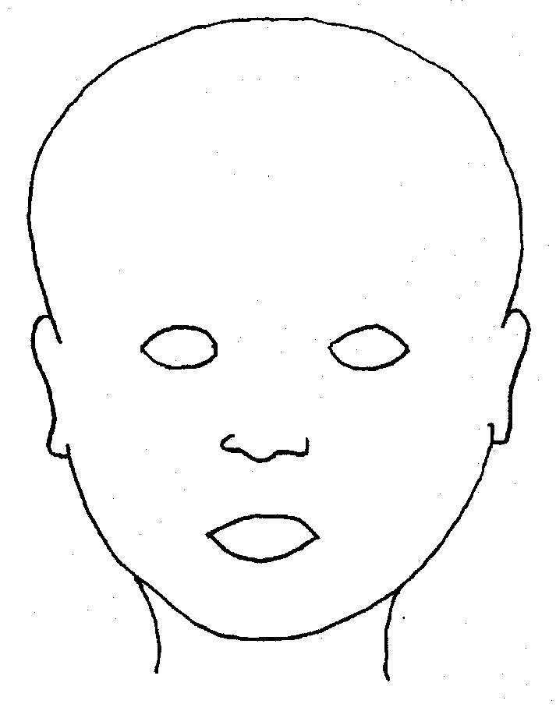 |  | 
FRONT |  | BACK
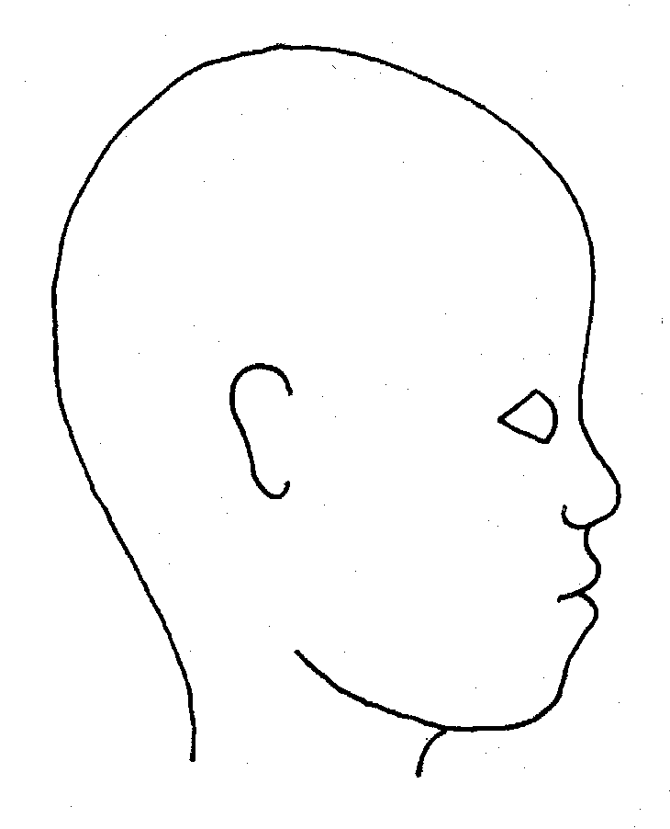 |  | 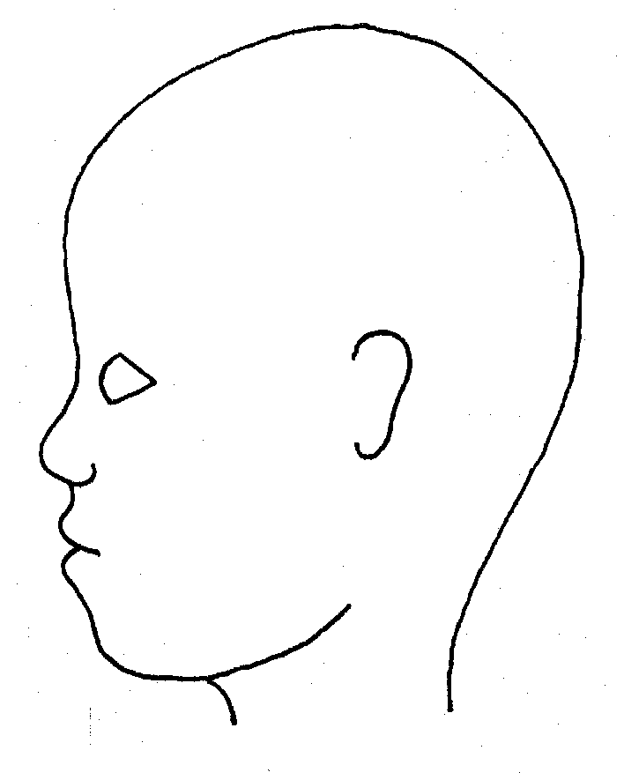
RIGHT |  | LEFT
Name of student: |  |  |  | Date and time of observation:
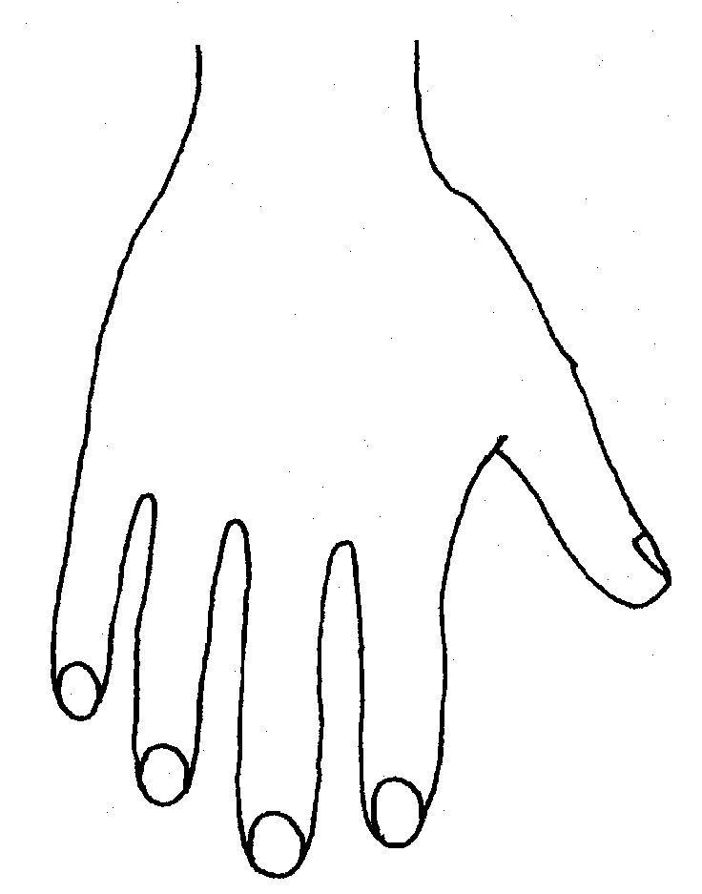 |  |  | 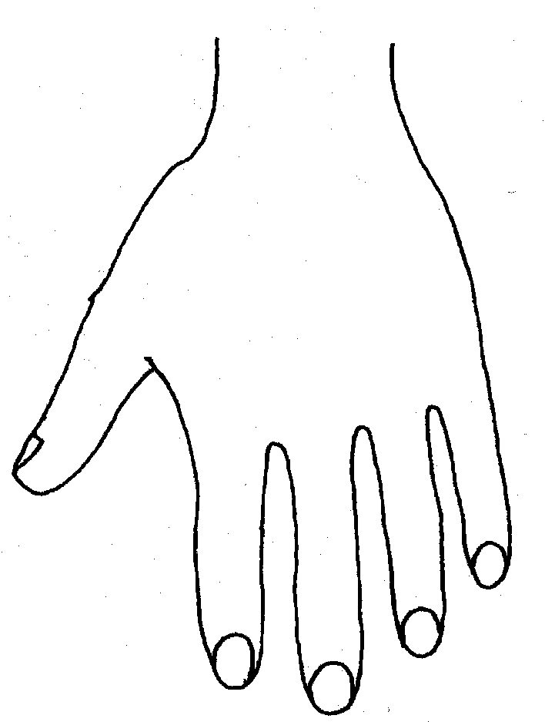
R |  |  | L


BACK


Name of student: ................................................... Date and time of observation: ........................................
R BOTTOM L
R TOP L
  INNER RIGHT |  |   INNER LEFT
OUTER LEFT
  OUTER RIGHT |  | 

Appendix Three – Allegations of abuse made against staff
Section 1: allegations that may meet the harms threshold
This section applies to all cases in which it is alleged that a current member of staff, including a supply teacher, volunteer or contractor, has:
- Behaved in a way that has harmed a child, or may have harmed a child, and/or
- Possibly committed a criminal offence against or related to a child, and/or
- Behaved towards a child or children in a way that indicates they may pose a risk of harm to children, and/or
- Behaved or may have behaved in a way that indicates they may not be suitable to work with children – this includes behaviour taking place both inside and outside of school
If we are in any doubt as to whether a concern meets the harm threshold, we will consult our local authority designated officer (LADO).
We will deal with any allegation of abuse quickly, in a fair and consistent way that provides effective child protection while also supporting the individual who is the subject of the allegation.
A ‘case manager’ will lead any investigation. This will be the headteacher, or the chair of governors where the headteacher is the subject of the allegation. The case manager will be identified at the earliest opportunity.
Our procedures for dealing with allegations will be applied with common sense and judgement.
If we receive an allegation of an incident happening while an individual or organisation was using the school premises to run activities for children, we will follow our safeguarding policies and procedures and inform our LADO.
Suspension of the accused until the case is resolved
Suspension of the accused will not be the default position and will only be considered in cases where there is reason to suspect that a child or other children is/are at risk of harm, or the case is so serious that there might be grounds for dismissal. In such cases, we will only suspend an individual if we have considered all other options available and there is no reasonable alternative.
Based on an assessment of risk, we will consider alternatives such as:
- Redeployment within the school so that the individual does not have direct contact with the child or children concerned.
- Providing an assistant to be present when the individual has contact with children.
- Redeploying the individual to alternative work in the school so that they do not have unsupervised access to children.
- Moving the child or children to classes where they will not meet the individual, making it clear that this is not a punishment and parents/carers have been consulted.
- Temporarily redeploying the individual to another role in a different location, for example to an alternative school or other work for the Trust.
If in doubt, the case manager will seek views from the school’s personnel adviser and the designated officer at the local authority, as well as the police and children’s social care where they have been involved.
Definitions for outcomes of allegation investigations
- Substantiated: there is sufficient evidence to prove the allegation
- Malicious: there is sufficient evidence to disprove the allegation and there has been a deliberate act to deceive, or to cause harm to the subject of the allegation
- False: there is sufficient evidence to disprove the allegation
- Unsubstantiated: there is insufficient evidence to either prove or disprove the allegation (this does not imply guilt or innocence)
- Unfounded: to reflect cases where there is no evidence or proper basis which supports the allegation being made
Procedure for dealing with allegations
In the event of an allegation that meets the criteria above, the case manager will take the following steps:
- Conduct basic enquiries in line with local procedures to establish the facts to help determine whether there is any foundation to the allegation before carrying on with the steps below
- Discuss the allegation with the designated officer at the local authority. This is to consider the nature, content and context of the allegation and agree a course of action, including whether further enquiries are necessary to enable a decision on how to proceed, and whether it is necessary to involve the police and/or children’s social care services. (The case manager may, on occasion, consider it necessary to involve the police before consulting the designated officer – for example, if the accused individual is deemed to be an immediate risk to children or there is evidence of a possible criminal offence. In such cases, the case manager will notify the designated officer as soon as practicably possible after contacting the police)
- Inform the accused individual of the concerns or allegations and likely course of action as soon as possible after speaking to the designated officer (and the police or children’s social care services, where necessary). Where the police and/or children’s social care services are involved, the case manager will only share such information with the individual as has been agreed with those agencies
- Where appropriate (in the circumstances described above), carefully consider whether suspension of the individual from contact with children at the school is justified or whether alternative arrangements such as those outlined above can be put in place. Advice will be sought from the designated officer, police and/or children’s social care services, as appropriate
- Where the case manager is concerned about the welfare of other children in the community or the individual’s family, they will discuss these concerns with the DSL and make a risk assessment of the situation. If necessary, the DSL may make a referral to children’s social care
- If immediate suspension is considered necessary, agree and record the rationale for this with the designated officer. The record will include information about the alternatives to suspension that have been considered, and why they were rejected. Written confirmation of the suspension will be provided to the individual facing the allegation or concern within 1 working day, and the individual will be given a named contact at the school and their contact details
- If it is decided that no further action is to be taken in regard to the subject of the allegation or concern, record this decision and the justification for it and agree with the designated officer what information should be put in writing to the individual and by whom, as well as what action should follow both in respect of the individual and those who made the initial allegation
- If it is decided that further action is needed, take steps as agreed with the designated officer to initiate the appropriate action in school and/or liaise with the police and/or children’s social care services as appropriate
- Provide effective support for the individual facing the allegation or concern, including appointing a named representative to keep them informed of the progress of the case and considering what other support is appropriate.
- Inform the parents or carers of the child/children involved about the allegation as soon as possible if they do not already know (following agreement with children’s social care services and/or the police, if applicable). The case manager will also inform the parents or carers of the requirement to maintain confidentiality about any allegations made against teachers (where this applies) while investigations are ongoing. Any parent or carer who wishes to have the confidentiality restrictions removed in respect of a teacher will be advised to seek legal advice
- Keep the parents or carers of the child/children involved informed of the progress of the case (only in relation to their child – no information will be shared regarding the staff member)
- Make a referral to the DBS where it is thought that the individual facing the allegation or concern has engaged in conduct that harmed or is likely to harm a child, or if the individual otherwise poses a risk of harm to a child
We will inform Ofsted of any allegations of serious harm or abuse by any person living, working, or looking after children at the premises (whether the allegations relate to harm or abuse committed on the premises or elsewhere), and any action taken in respect of the allegations. This notification will be made as soon as reasonably possible and always within 14 days of the allegations being made.
If the school is made aware that the secretary of state has made an interim prohibition order in respect of an individual, we will immediately suspend that individual from teaching, pending the findings of the investigation by the Teaching Regulation Agency.
Where the police are involved, wherever possible the school will ask the police at the start of the investigation to obtain consent from the individuals involved to share their statements and evidence for use in the school’s disciplinary process, should this be required at a later point.
Additional considerations for supply teachers and all contracted staff
If there are concerns or an allegation is made against someone not directly employed by the school, such as a supply teacher or contracted staff member provided by an agency, we will take the actions below in addition to our standard procedures.
- We will not decide to stop using an individual due to safeguarding concerns without finding out the facts and liaising with our LADO to determine a suitable outcome.
- The governing board will discuss with the agency whether it is appropriate to suspend the individual, or redeploy them to another part of the school, while the school carries out the investigation.
- We will involve the agency fully, but the school will take the lead in collecting the necessary information and providing it to the LADO as required.
- We will address issues such as information sharing, to ensure any previous concerns or allegations known to the agency are considered (we will do this, for example, as part of the allegations management meeting or by liaising directly with the agency where necessary)
When using an agency, we will inform them of our process for managing allegations, and keep them updated about our policies as necessary, and will invite the agency's HR manager or equivalent to meetings as appropriate.
Timescales
We will deal with all allegations as quickly and effectively as possible and will endeavour to comply with the following timescales, where reasonably practicable:
- Any cases where it is clear immediately that the allegation is unsubstantiated or malicious should be resolved within 1 week
- If the nature of an allegation does not require formal disciplinary action, appropriate action should be taken within 3 working days
- If a disciplinary hearing is required and can be held without further investigation, this should be held within 15 working days
However, these are objectives only and where they are not met, we will endeavour to take the required action as soon as possible thereafter.
Specific actions
Action following a criminal investigation or prosecution
The case manager will discuss with the local authority’s designated officer whether any further action, including disciplinary action, is appropriate and, if so, how to proceed, taking into account information provided by the police and/or children’s social care services.
Conclusion of a case where the allegation is substantiated
If the allegation is substantiated and the individual is dismissed or the school ceases to use their services, or the individual resigns or otherwise ceases to provide their services, the school will make a referral to the DBS for consideration of whether inclusion on the barred lists is required.
If the individual concerned is a member of teaching staff, the school will consider whether to refer the matter to the Teaching Regulation Agency to consider prohibiting the individual from teaching.
Individuals returning to work after suspension
If it is decided on the conclusion of a case that an individual who has been suspended can return to work, the case manager will consider how best to facilitate this.
The case manager will also consider how best to manage the individual’s contact with the child or children who made the allegation, if they are still attending the school.
Unsubstantiated, unfounded, false or malicious reports
If a report is:
- Determined to be unsubstantiated, unfounded, false or malicious, the DSL will consider the appropriate next steps. If they consider that the child and/or person who made the allegation is in need of help, or the allegation may have been a cry for help, a referral to children’s social care may be appropriate
- Shown to be deliberately invented, or malicious, the school will consider whether any disciplinary action is appropriate against the individual(s) who made it
Unsubstantiated, unfounded, false or malicious allegations
If an allegation is:
- Determined to be unsubstantiated, unfounded, false or malicious, the LADO and case manager will consider the appropriate next steps. If they consider that the child and/or person who made the allegation is in need of help, or the allegation may have been a cry for help, a referral to children’s social care may be appropriate
- Shown to be deliberately invented, or malicious, the school will consider whether any disciplinary action is appropriate against the individual(s) who made it
Confidentiality and information sharing
The school will make every effort to maintain confidentiality and guard against unwanted publicity while an allegation is being investigated or considered.
The case manager will take advice from the LADO, police and children’s social care services, as appropriate, to agree:
- Who needs to know about the allegation and what information can be shared
- How to manage speculation, leaks and gossip, including how to make parents or carers of a child/children involved aware of their obligations with respect to confidentiality
- What, if any, information can be reasonably given to the wider community to reduce speculation
- How to manage press interest if, and when, it arises
Record-keeping
The case manager will maintain clear records about any case where the allegation or concern meets the criteria above and store them on the individual’s confidential personnel file for the duration of the case.
The records of any allegation that, following an investigation, is found to be malicious or false will be deleted from the individual’s personnel file (unless the individual consents for the records to be retained on the file).
For all other allegations (which are not found to be malicious or false), the following information will be kept on the file of the individual concerned:
- A clear and comprehensive summary of the allegation
- Details of how the allegation was followed up and resolved
- Notes of any action taken, decisions reached and the outcome
- A declaration on whether the information will be referred to in any future reference
In these cases, the school will provide a copy to the individual, in agreement with children’s social care or the police as appropriate.
We will retain all records at least until the accused individual has reached normal pension age, or for 10 years from the date of the allegation if that is longer.

References
When providing employer references, we will:
- Not refer to any allegation that has been found to be false, unfounded, unsubstantiated or malicious, or any repeated allegations which have all been found to be false, unfounded, unsubstantiated or malicious
- Include substantiated allegations, provided that the information is factual and does not include opinions
Learning lessons
After any cases where the allegations are substantiated, the case manager will review the circumstances of the case with the local authority’s designated officer to determine whether there are any improvements that we can make to the school’s procedures or practice to help prevent similar events in the future.
This will include consideration of (as applicable):
- Issues arising from the decision to suspend the member of staff
- The duration of the suspension
- Whether or not the suspension was justified
- The use of suspension when the individual is subsequently reinstated. We will consider how future investigations of a similar nature could be carried out without suspending the individual
For all other cases, the case manager will consider the facts and determine whether any improvements can be made.
Non-recent allegations
Abuse can be reported, no matter how long ago it happened.
We will report any non-recent allegations made by a child to the LADO in line with our local authority’s procedures for dealing with non-recent allegations.
Where an adult makes an allegation to the school that they were abused as a child, we will advise the individual to report the allegation to the police.
Section 2: concerns that do not meet the harm threshold
This section applies to all concerns (including allegations) about members of staff, including supply teachers, volunteers and contractors, which do not meet the harm threshold set out in section 1 above.
Concerns may arise through, for example:
- Suspicion
- Complaint
- Safeguarding concern or allegation from another member of staff
- Disclosure made by a child, parent or other adult within or outside the school
- Pre-employment vetting checks
We recognise the importance of responding to and dealing with any concerns in a timely manner to safeguard the welfare of children.
Definition of low-level concerns
The term ‘low-level’ concern is any concern – no matter how small – that an adult working in or on behalf of the school may have acted in a way that:
- Is inconsistent with the staff code of conduct, including inappropriate conduct outside of work, and
- Does not meet the allegations threshold or is otherwise not considered serious enough to consider a referral to the designated officer at the local authority
Examples of such behaviour could include, but are not limited to:
- Being overly friendly with children
- Having favourites
- Taking photographs of children on their mobile phone
- Engaging with a child on a one-to-one basis in a secluded area or behind a closed door
- Humiliating pupils
Sharing low-level concerns
We recognise the importance of creating a culture of openness, trust and transparency to encourage all staff to confidentially share low-level concerns so that they can be addressed appropriately.
We will create this culture by:
- Ensuring staff are clear about what appropriate behaviour is and are confident in distinguishing expected and appropriate behaviour from concerning, problematic or inappropriate behaviour, in themselves and others
- Empowering staff to share any low-level concerns as per section 7.7 of this policy
- Empowering staff to self-refer
- Addressing unprofessional behaviour and supporting the individual to correct it at an early stage
- Providing a responsive, sensitive and proportionate handling of such concerns when they are raised
- Helping to identify any weakness in the school’s safeguarding system
Responding to low-level concerns
If the concern is raised via a third party, the headteacher will collect evidence where necessary by speaking:
- Directly to the person who raised the concern, unless it has been raised anonymously
- To the individual involved and any witnesses
The headteacher will use the information collected to categorise the type of behaviour and determine any further action, in line with the school’s staff conduct. The headteacher will be the ultimate decision-maker in respect of all low-level concerns, though they may wish to collaborate with the DSL.
Keeping Children Safe in Education also links to this report for more information Developing and implementing a low-level concerns policy: A guide for organisations which work with children]
Record keeping
All low-level concerns will be recorded in writing. In addition to details of the concern raised, records will include the context in which the concern arose, any action taken and the rationale for decisions and action taken.
Records will be:
- Kept confidential, held securely, and comply with the DPA 2018 and UK GDPR
- Reviewed so that potential patterns of concerning, problematic or inappropriate behaviour can be identified. Where a pattern of such behaviour is identified, we will decide on a course of action, either through our disciplinary procedures or, where a pattern of behaviour moves from a concern to meeting the harms threshold as described in section 1 of this appendix, we will refer it to the designated officer at the local authority.
- Retained at least until the individual leaves employment at the school
Where a low-level concern relates to a supply teacher or contractor, we will notify the individual’s employer, so any potential patterns of inappropriate behaviour can be identified.
References
We will not include low-level concerns in references unless:
- The concern (or group of concerns) has met the threshold for referral to the designated officer at the local authority and is found to be substantiated; and/or
- The concern (or group of concerns) relates to issues which would ordinarily be included in a reference, such as misconduct or poor performance

Appendix Four – Tracking form: concerns raised against staff
Tracking Form
Concern raised against Staff

When an allegation/concern is identified brief details should be obtained and passed to the Head Teacher as soon as possible.

Date: |  | Time
Allegation/Concern made by:

Who the allegation/concern is made against:

NB: The subject of the allegation should not be informed without first seeking advice
Allegation/concern first received by:

Brief details of the allegation:

Date of alleged/concern incident:
Does this allegation involve a restraint? | YES / NO / NYK
Case manager appointed and to complete tracking form

Allegations which appear to meet the criteria should be referred to LADO within 24 hours ( see Note 1)

Does this appear to meet the criteria for a LADO referral? | YES / NO
If no, are you recording the incident as a Low-Level Concern? | YES / NO
Referred to LADO: | YES / NO Date:
Advice given:

Date:
Action to be taken:

Suspension should never be automatic but should be considered and rationale given for decisions made. See Appendix B | Decision to suspend YES / NO / NA

Information gathered about the allegation
Staff witnesses | Account taken | Copy forwarded to LADO
1.
2.
3.
Student witnesses
1.
2.
3.
4
Plan of setting/classroom etc
Chronology of events
1st Aid log

Full details gathered
Student name:
Date of Birth
Address:

Is the student known to Social Care? | YES / NO
Does the student have Special Educational Needs? | YES / NO If yes - details
Has the student raised previous concerns? | YES / NO If yes - details
Staff full name:

Date of Birth:
Address:

Has this person raised concerns before?

Informing others
Have parents of the student been informed?
Details of response

Staff members should be informed of the allegation ASAP - on advice from LADO
Has the staff member been informed? | YES / NO
Name of Key person nominated to feedback to them:
Outcome of LADO consultation
Does this meet LADO criteria: | YES / NO
Further action required:

Professional Strategy Meeting to be held: | YES / NO /NA
Professional Strategy Meeting date:
Attended by Case Manager: | YES / NO / NA
Minutes received: | YES / NO /NA
Outcome: – please circle | Unfounded Unsubstantiated  False Substantiated  Malicious
The information will be referred to in any future reference | YES/NO
Disciplinary investigation to be held: | YES / NO / NA
Staff member informed of outcome: | YES / NO
Parents informed of outcome (no info about the staff member should be shared): | YES / NO
Chair of governors informed: | YES / NO /NA
Trust Safeguarding Lead informed: | YES / NO /NA
Details added to overview table: | YES / NO
Outcome:

Lessons learned:

Appendix Five - Statement of Staff Commitment to the Forward As One Safeguarding & Child Protection Policy
To be completed annually BY ALL STAFF and kept in Personnel Files

Staff Member:………………………………………Post:……………………………..

Line Manager:………………………………………………………

I have read and understood the standards and guidelines outlined in the 2026 Safeguarding & Child Protection Policy.
I agree with the principles contained therein and accept the importance of implementing the policies and practices whilst working at Gorsefield Primary School.
I confirm that I have:
- Received a copy of Safeguarding & Child Protection Policy
- Had the opportunity to read and discuss the policy and procedure with my Line Manager
- Discussed and recorded training requirements for ongoing action.

Signed (Staff)………………………………………………………………………

Signed (Line Manager)……………………………………………………………

Date …………………………………….

Appendix Six – Criminal records self-declaration form
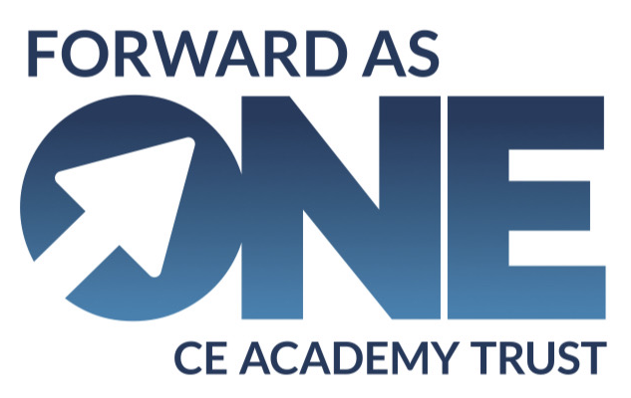
Criminal records self-declaration form 2026 (academies)
To be completed annually in September BY ALL STAFF
As part of our duty to safeguard pupils, we need to check whether you are barred from working with children, or whether you have convictions that would make you unsuitable to work with children. Please complete the following form as accurately as possible.
Note: you are not required to disclose convictions or cautions that are ‘protected’, as defined by the Rehabilitation of Offenders Act 1974 (Exceptions) Order 1975 (as amended in 2013). If you’re not sure whether one of your convictions is ‘protected’, you can check here.

Name
Role

Self-declaration
Yes/No
Are you barred from working in regulated activity with children (i.e., are you included on the Disclosure and Barring Service Children’s Barred List)?
Do you have any unspent conditional cautions or convictions under the Rehabilitation of Offenders Act 1974?
Do you have any adult cautions (simple or conditional) or spent convictions that are not protected as defined by the Rehabilitation of Offenders Act 1974 (Exceptions) Order 1975 (Amendment) (England and Wales) Order 2020?
Have you committed an offence overseas which would have resulted in disqualification if it had occurred in the UK?
Are you subject to a section 128 direction?
Have any orders relating to the care of children, as set out in schedule 1 of the Childcare (Disqualification) and Childcare (Early Years Provision Free of Charge) (Extended Entitlement) (Amendment) Regulations 2018, been made in respect of you?
This includes, but is not limited to:
- Orders disqualifying you from caring for children
- Orders disqualifying you from private fostering
- Any refusal of an application for you to be registered in relation to a children’s home
- Care/child protection orders issued in respect of a child in your care
Have you been convicted of committing, or been given a caution, reprimand or warning since 6 April 2007 for, any offences set out in regulation 4 and schedules 2 and 3 of the Childcare (Disqualification) and Childcare (Early Years Provision Free of Charge) (Extended Entitlement) (Amendment) Regulations 2018?
This includes, but is not limited to:
- Any offence against or involving a child
- Any sexual offence
- Any violent offence, i.e. murder, manslaughter, kidnapping, false imprisonment, actual bodily harm (ABH), or grievous bodily harm (GBH)
Do the police or children’s social care have your name and/or information on file for any reason?
If you answered ‘yes’ to any of the questions above, please provide further information.

I confirm that the information above is accurate to the best of my knowledge, and that I will make the school aware of any changes in my circumstances that may affect the answers I’ve provided above, or my suitability for the job.

Signed: _________________________________________

Date: ___________________________

Appendix Seven - Related safeguarding policies
- Allergy safety policy
- Anti bullying policy
- Behaviour policy
- Complaints procedure
- Confidentiality and information sharing
- Intimate care policy
- Mobile phone policy
- Physical intervention and the use of reasonable force
- Promoting good attendance policy
- Pupil mental health and wellbeing policy
- SEND
- Staff behaviour/code of conduct
- Supporting pupils with medical conditions
- Suspensions and exclusions policy
- Visitor and volunteer policy
- Whistleblowing

